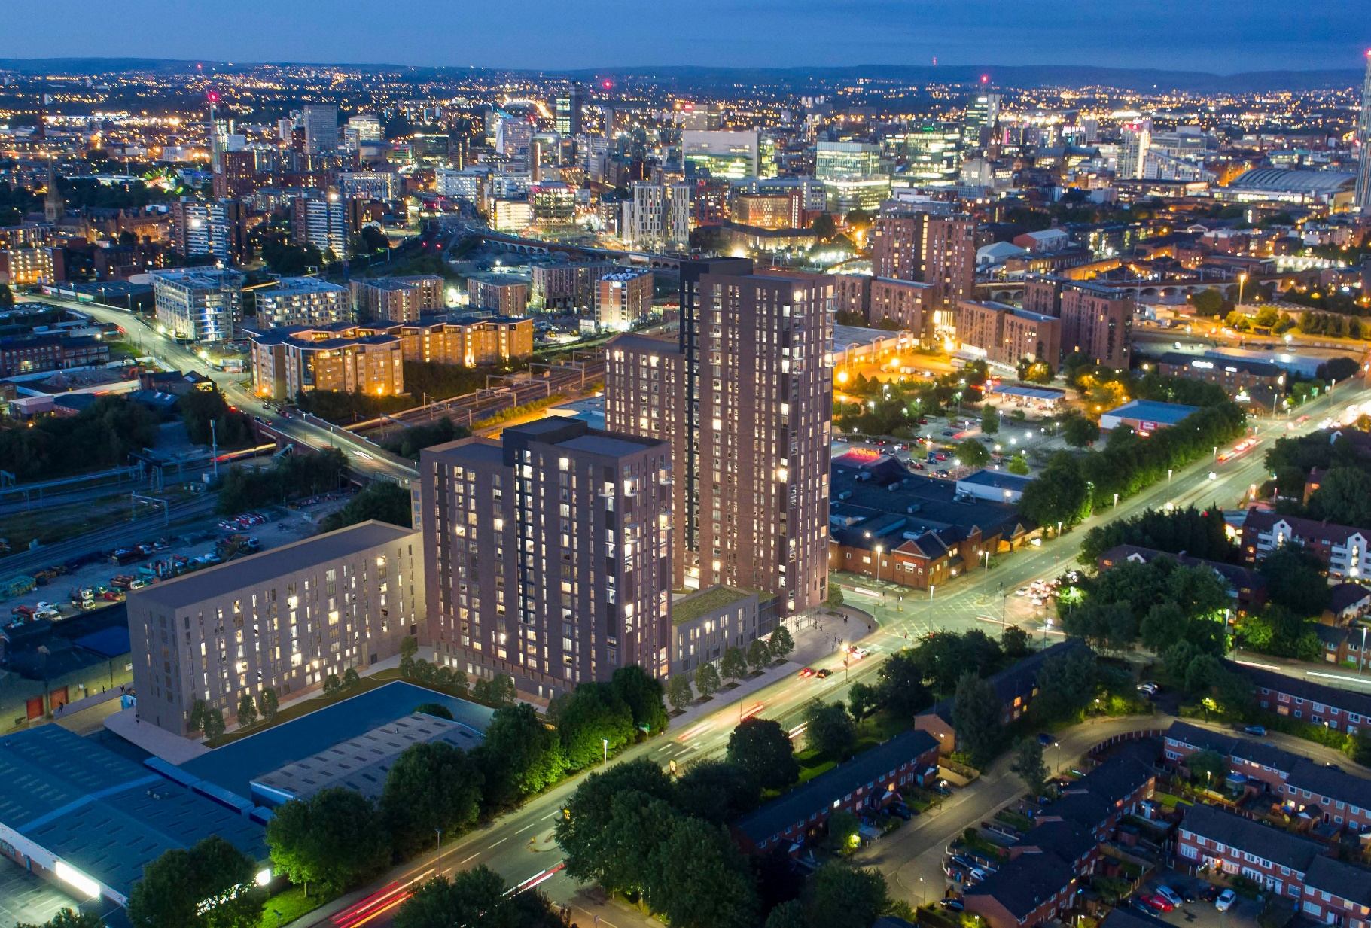
www.sourceddevelopmentgroup.com

Construction Team Update
MAY 2021

Construction Update

MAY 2021

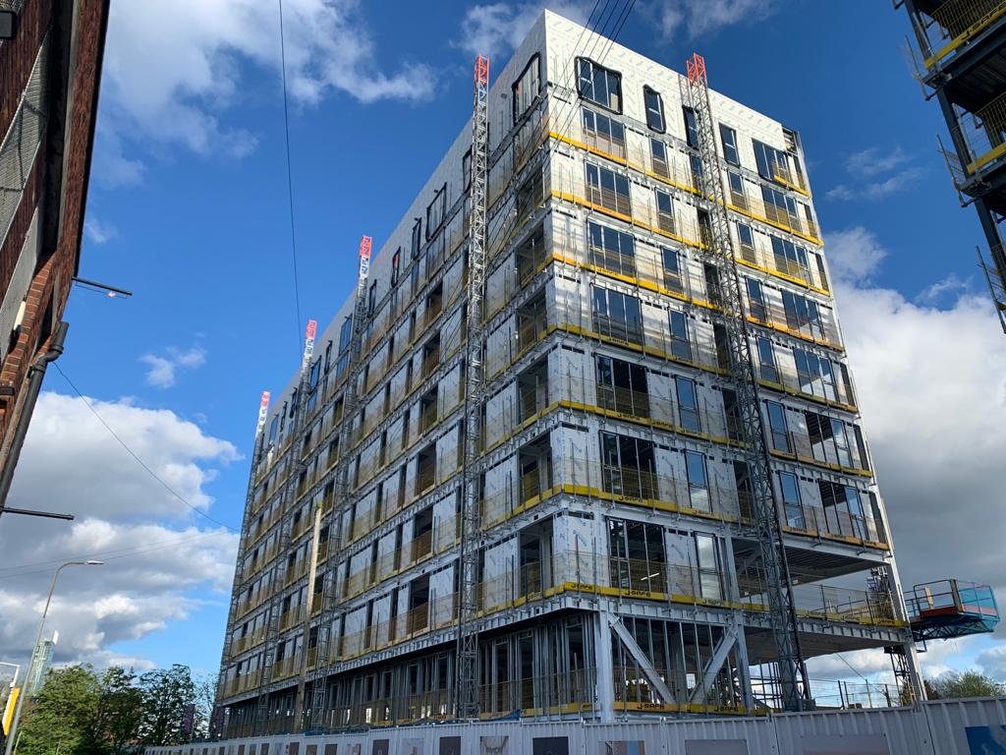

Current Status On Site

During May:
Block B, the SFS and Glassroc weather board continued to the external envelope, windows and glass floors 9,8,7,5 and both gables are 90% glazed also progressed. Internal walls commenced to floors 7,6, and 5. MEP on going to floors 9,8, and 7, and plywood pattresses have been installed in the walls ready for fixtures and fittings. Roof drainage is installed and connected, and the central core blockwork is 95% complete.

Block C, Steelwork is fully completed and handed over, floors are 50% complete and concreted to the 7 floors. Intumescent painting to the steelwork has commenced.

Block D, Pile Mat was civilised and CBR tested and Piling undertaken and completed. Pile cap bases have bee marked out ready for excavations to begin.

Planned works in the next period.

Block B
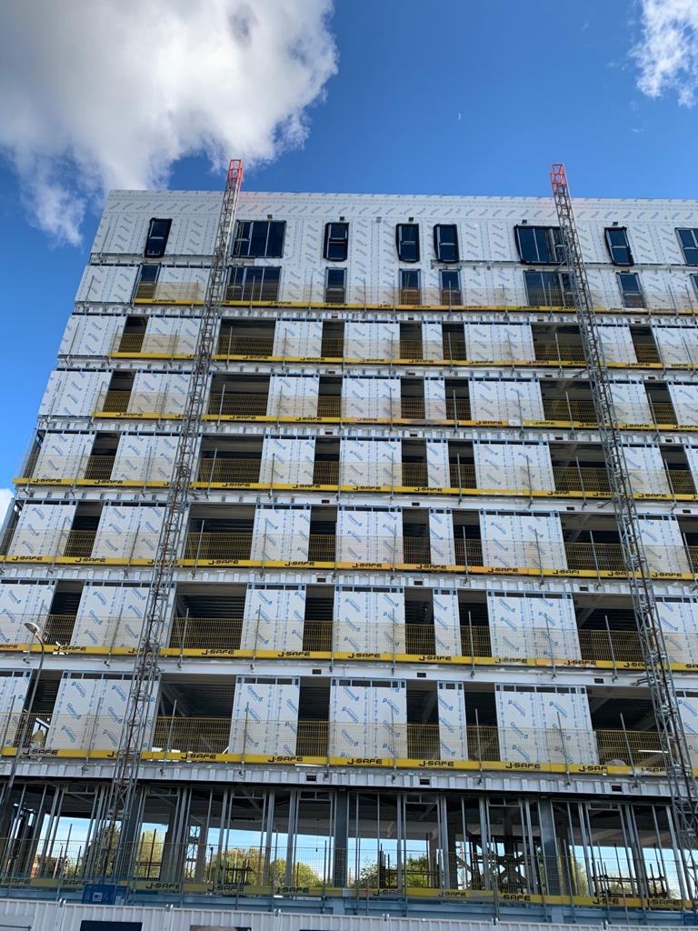
Continuation of the window installation complete with glazing, continuation of partitions and plasterboard, completion of the blockwork, continuation of the external façade, continuation of the MEP installation, continuation of 1st fix joinery
Completion of the central core blockwork. Commencing second siding the walls with plasterboard taping and jointing of the plasterboard ready for the mist coat of paint.

Block C
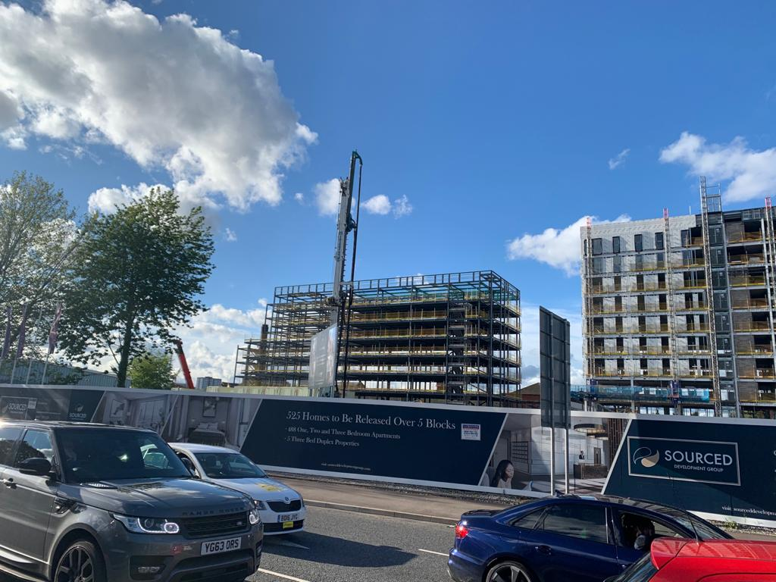
Completion of the metal decking to the floors and roof, completion of the concreting to the floors, we will be commencing the roof membrane, and installing mast climbers and another hoist. We will be commencing the SFS to the perimeter of the building and finally commencing the Blockwork to the stair and lift cores

Block D
Concreting to the pads and beams to the substructure of the building

Design works

The consultants engaged so far are:

Fletcher Rae Architects

A team of 5 directors, architects and technicians from Fletcher Rae are actively involved in the project. Tender information has been provided to test the market and construction drawings and specification issued for construction purposes. As Lead Designer, Fletcher Rae are coordinating the design.

SWF Consulting Ltd

SWF were engaged in November 2019 to provide civil and structural engineering services, working alongside the Architects, MEP Consultants and Sourced Development to progress the civil & structural design.
SWF provided suitable design and drawings to satisfy one of the pre- commencement planning conditions, as well as United Utilities’ approval the drainage scheme.
They have also provided design and drawings for foundations and the superstructure steelwork frame.

Tier Environmental Services

Completed Phase 2 ground investigation work and issued their report, which was submitted to Salford City Council. The findings of the report informed the design of the piles and foundations of Block C.
Earth Environmental & Geotechnical

Engaged to assess ground gases and a remediation strategy, all of which were completed and submitted to Salford City Council. The findings of the report were to the satisfaction of Salford City Council to enable the discharge of pre-commencement conditions.

QED – M&E Designers

Responsible for the design of all the electrical, plumbing, extract and supply ventilation systems, above ground drainage systems and all other elements of the incoming services.

Sourced Development Group – Principal Designer/CDM

SDG have appointed an in -house principal designer. The pre-construction information pack, produced by the previous Principal Designer, has been reviewed and found
to be adequate for the project and issued to Sourced Construction Group. Vernon chairs all the design and subcontractors’ meetings and, therefore, perfectly placed to assess
and advise on Designer’s responsibilities and duties regarding Health & Safety.

Omega Fire/BB7

Working as a specialist alongside all other designers to ensure that the overall design satisfies all relevant regulations and requirements. Omega Fire have been liaising with Fletcher Rae and QED and issued an updated report.

Building Control

Building Consents Ltd have been employed to carry out all necessary plan checks and to work alongside the other designers to ensure that all required building regulations are achieved. Their details have been forwarded to Helix to arrange for site inspections at regular intervals.

Red Acoustics

Working alongside the architects and other designers to ensure that the acoustic properties of the development satisfy
the standards required. They have issued their report, which will inform the final specification of the external façade.

Indigo/WSP Planning Consultants

Involved with the project over the last six months, coordinating and collating all necessary information for submission and discharge of pre-commencement conditions.

PGLA Landscape Architects

PGLA have been appointed to provide full design and details for the Car Park podium roof, as well as the overall site’s soft and hard standing areas. Some initial proposals have been shared with the team for review and comments.

Architectural

Fletcher Rae have progressed their design for Blocks A, C, D and E, as well as the Car Park, and have been liaising with the rest of the design team with exchange of models and CAD files.

Fletcher Rae have issued a full pack of construction information for Block B and C and are addressing site queries from the Principal Contractor.

Building setting out and general arrangement plans, fire strategy and internal partitions layouts for Block C, have been issued for construction purposes.

Block D design has been finalised and is now fully coordinated with the Structural Engineer’s and MEP Consultant’s layouts.

Block A design is being coordinated with SWF Consulting and QED, with input from the Fire Engineer.

The Car Park layouts have now been fully coordinated with the Landscape Architect and Structural Engineer.

External landscape details have been reviewed and commented upon by Fletcher Rae.

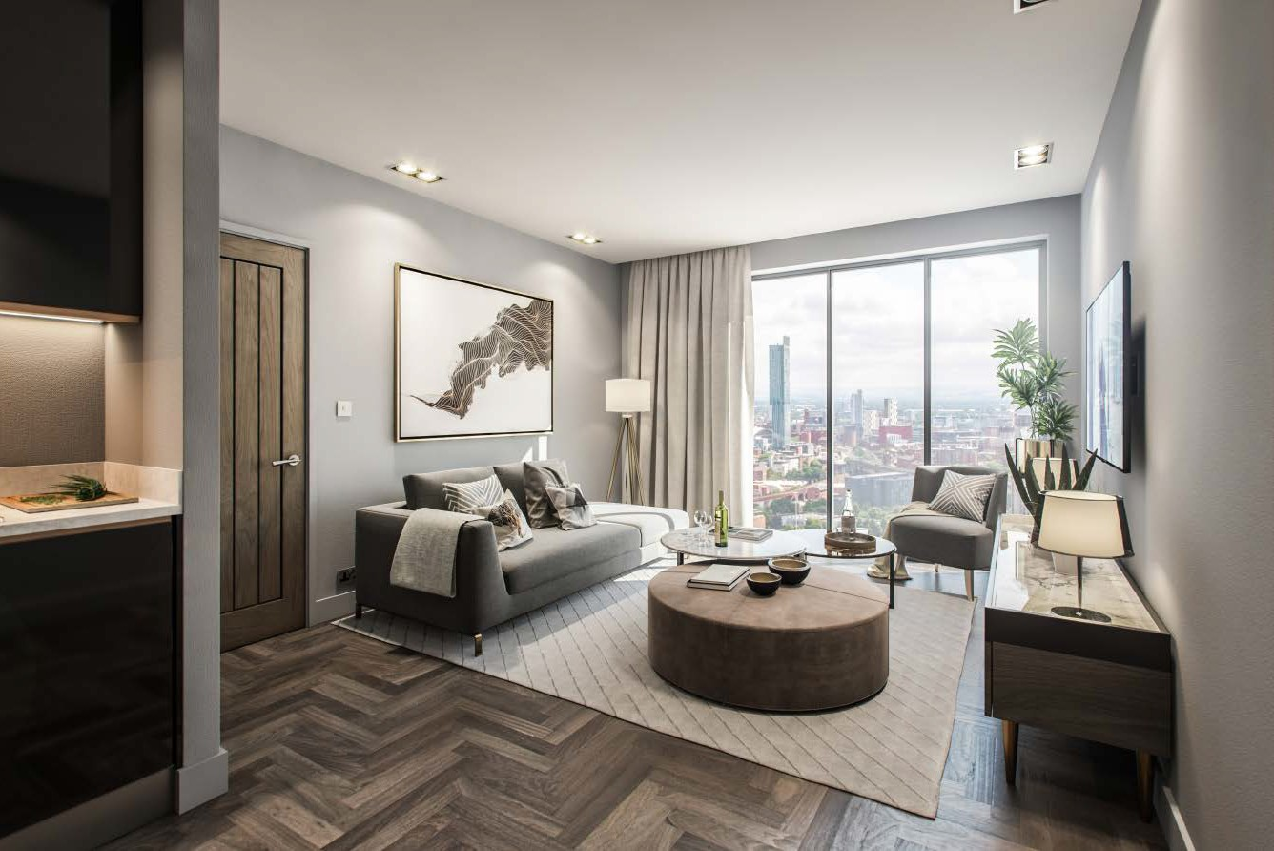

Civil & Structural Engineering

SWF Consulting visited site to inspect Block B upper floors’ concrete being poured and commented on SFS subcontractor’s design.

All Block C construction information, including drainage, sub structure and superstructure, has been issued to the Principal Contractor. A full set of calculations, for Block C, has been issued to the appointed independent Building Control for approval.

A full set of superstructure layouts and drainage information for Block D for construction purposes

A set of first and second floor steelwork and slab layouts have been issued for the CAR Park, with the foundations to follow shortly.

SWF have been liaising with Highways and are updating their 278 Works details to their requirements.

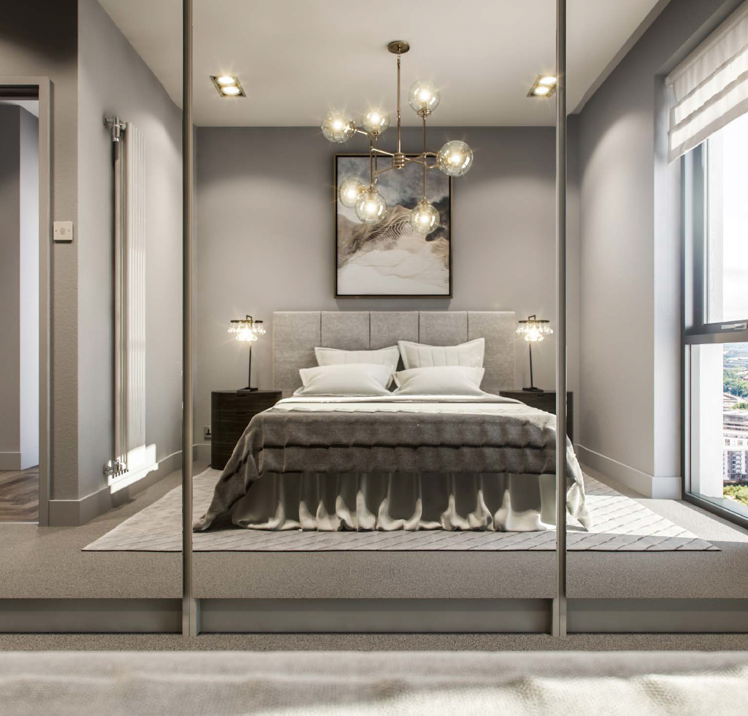

MEP Engineering

QED have been liaising with Fletcher Rae to agree the pop-up locations, for Block C, to inform the below ground drainage design by SWF. They have, also, issued a full set of their performance mechanical and electrical drawings and specifications for this block.

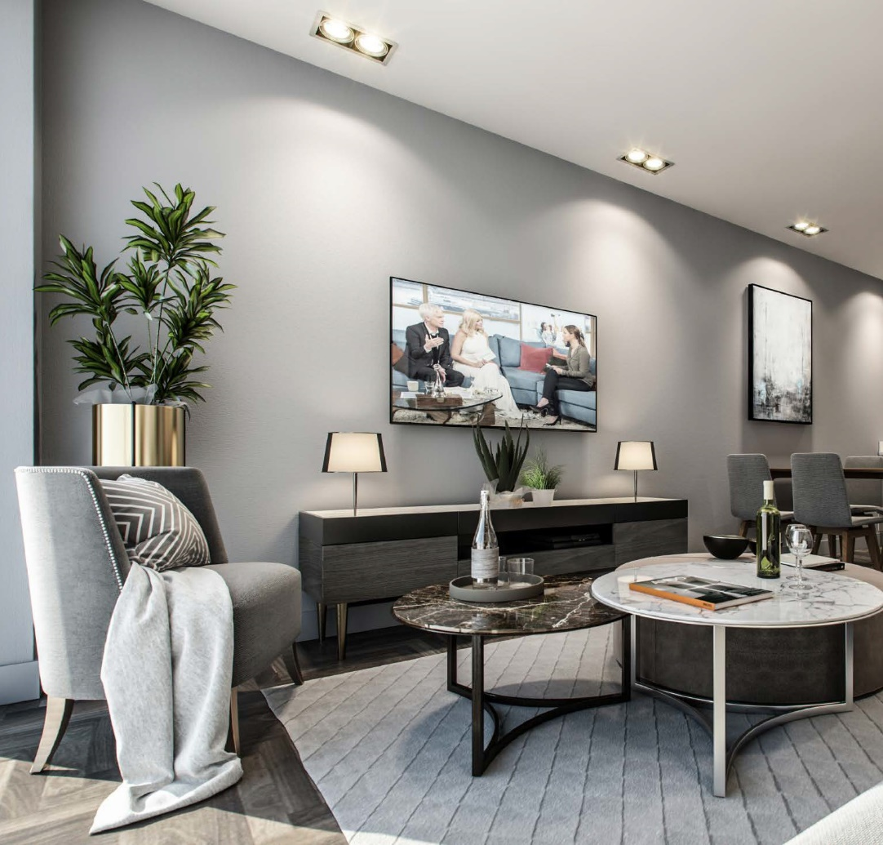
Having developed the design and details of the perimeter walls, SAP calculations and overheating assessments have been revisited and improved results provided for Block C.
A set of mechanical and electrical drawings, as well as overheating calculations and SAP analysis, for Block D have been issued. A copy of the mechanical and electrical specifications to follow, shortly.

QED are now coordinating the pop-up locations for Blocks A & E, as well space planning of the services to allow steelwork penetrations to be finalised.

QED have now been appointed by our MEP contractor to provide a fully coordinated design

QED have been attending design team meetings and workshops with the rest of the design team.

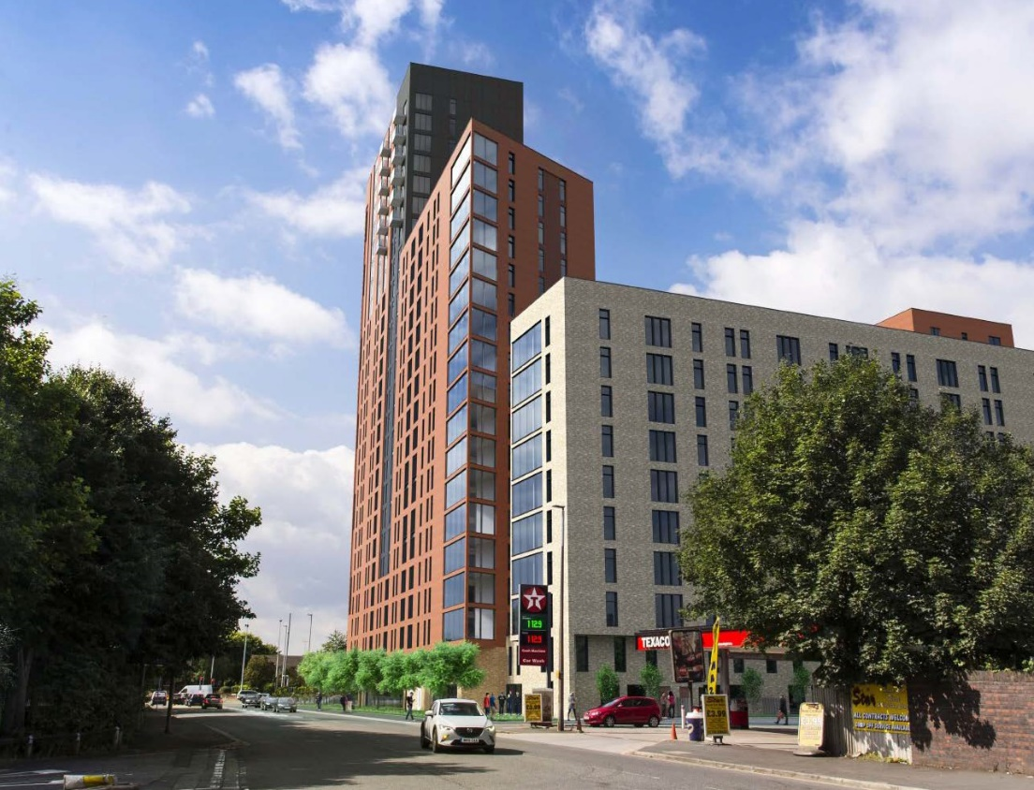

Issue a coordinated set of architectural, structural and MEP drawings for Block D as well as for the Car Park for tender purposes – ongoing.

Issue all construction information for Block D and in particular for the RC core although we have the start bars designed into the substructure works

Final coordination of the external landscape, including drainage and lighting, between the consultants.

Work with the construction team on
on closing out design development
and technical details.

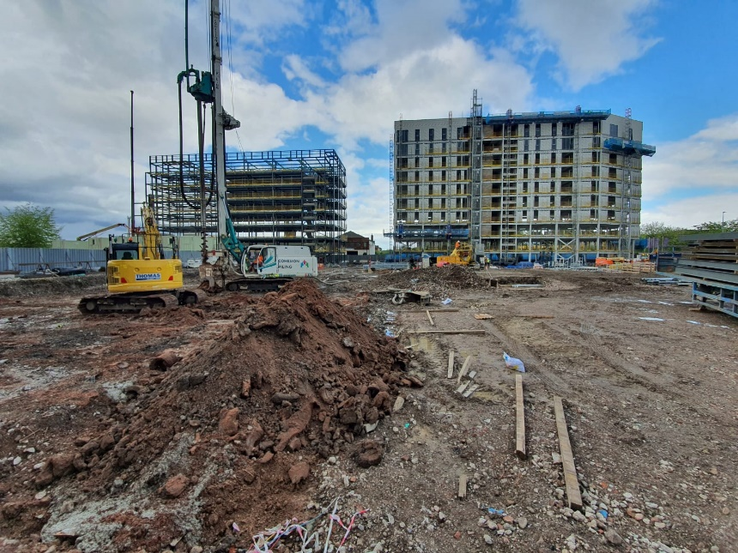
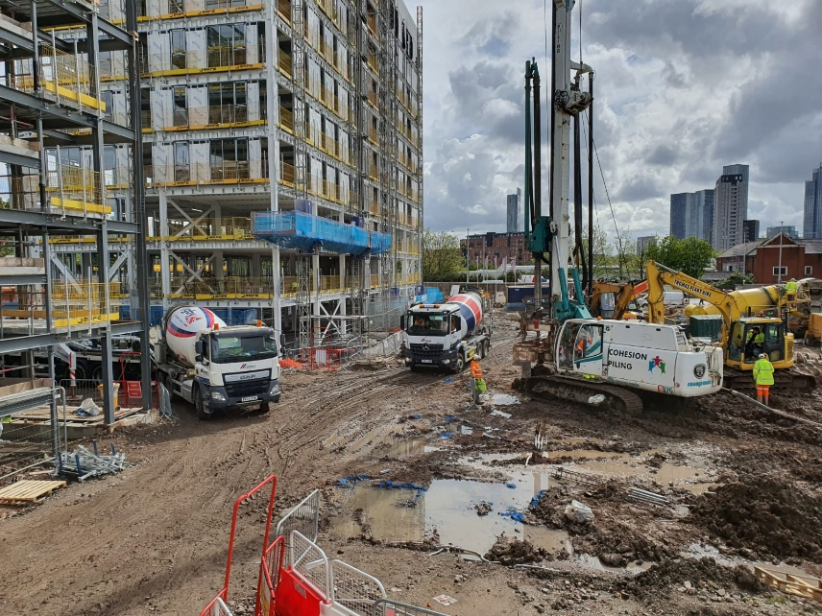
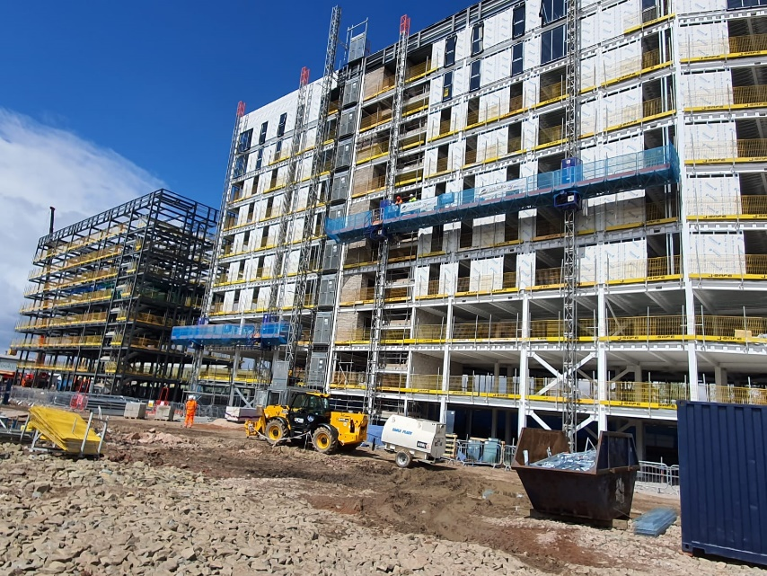
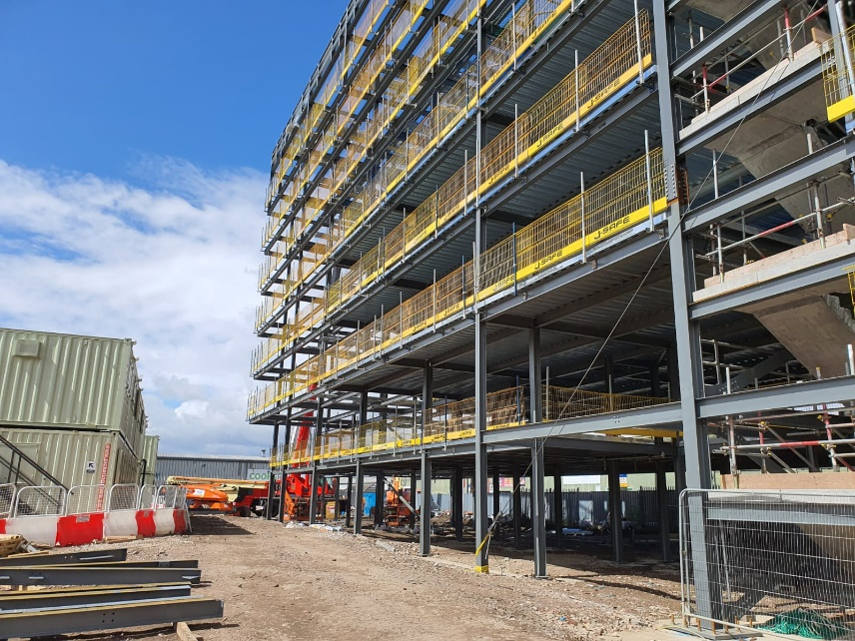
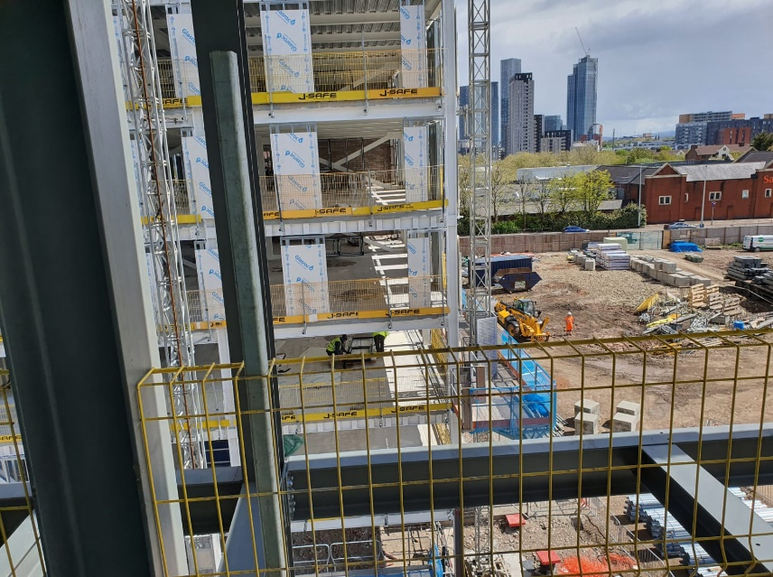
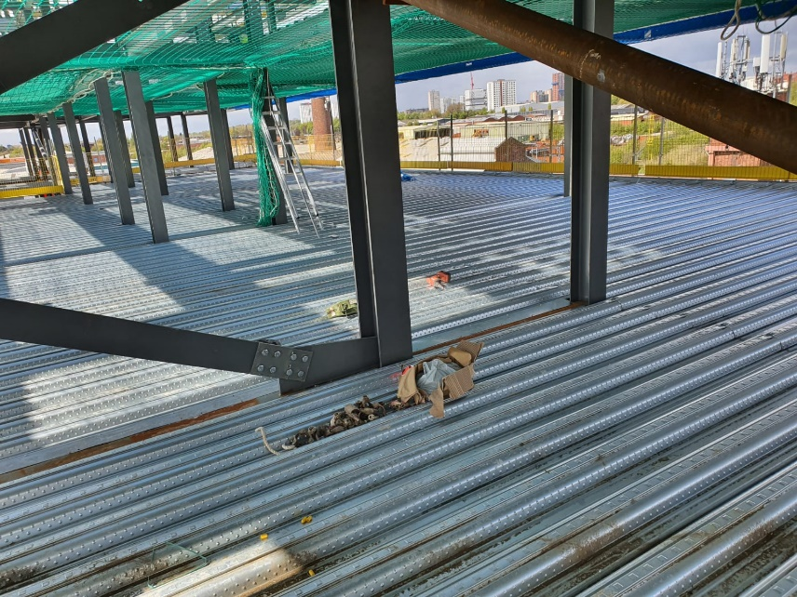

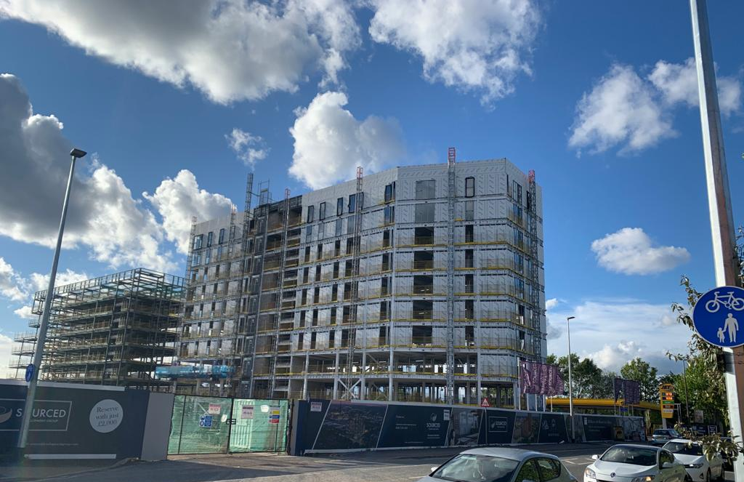
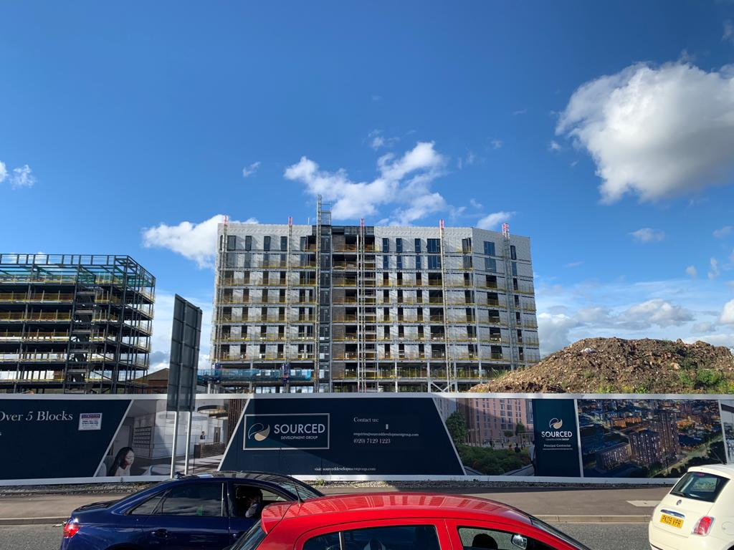

www.sourceddevelopmentgroup.com

The information contained with this document is a general guide. This information does not constitute an offer or a contract and we (or anyone in our company) do not imply, make or give any representation, guarantee or
warranty whatsoever relating to the terms contained herein. Any intending investor must satisfy themselves as to the correctness of any of the statements, plans or images contained herein. Images are for reference purposes only.

